­

Web Technology

Assignment-1

By: Vasu Sehgal

Roll no. : 46

**Ques1 Create a HTML Form using as many number of form fields as available in HTML.**

Ans1: Web tech form page.html

<html>

   <head>

      <title>Survey Form</title>

      <link rel="stylesheet" href="style.css">

   </head>

   <body>

      <h1 id="title">Online Class Survey Form</h1>

      <p id="description">Thank you for taking the time to help us improve the quality of classes</p>

      <form action="#" id="survey-form">

         <label for="name" id="name-label">Name</label><br>

         <input type="text" id="name" placeholder="Enter your name" required><br><br>

         <label for="email" id="email-label" type="email">Email</label><br>

         <input type="email" id="email" placeholder="Enter your Email Id" required><br><br>

         <label for="pass" id="pass-label" type="password">Password for Online Class</label><br>

         <input type="password" id="pass" placeholder="Enter your Online Class Password" required><br><br>

         <label for="number" id="number-label">Age (Optional)</label><br>

         <input type="number" id="number" min="10" max="99" placeholder="Age"><br>

         <label for="dropdown" id="drop">Your Current Role in DUCS?</label><br><br>

         <select name="" id="dropdown">

            <option value="">Select an option</option>

            <option value="">Student</option>

            <option value="">Teacher</option>

            <option value="">Non Teaching Staff</option>

            <option value="">Other</option>

         </select><br><br>

        <label for="recomm">How are Online Classes?</label>

         <ul id="radio" style="list-style-type:none;">

         <li><input type="radio" name="recomm" value="0"> Not So Good</li>

         <li><input type="radio" name="recomm" value="0"> Very Good</li>

         <li><input type="radio" name="recomm" value="0"> Amazing</li>

         </ul>

        <br>

         <label for="best">What is your favorite Online Class this Semester?</label><br>

         <select name="best" id="best">

            <option value="">Select an option</option>

            <option value="">Web Technologies</option>

            <option value="">Automata Theory</option>

            <option value="">Information Security</option>

            <option value="">Operating sysetms</option>

        </select>

        <br>

            <label>What would you like to see improved?</label><br>

            <ul id="chck-box" style="list-style-type:none;">

               <li><input type="checkbox" value="front-end">Course Content</li>

               <li><input type="checkbox" value="back-end">Regular Classes</li>

               <li><input type="checkbox" value="data-visualization">Online Class Software</li>

               <li><input type="checkbox" value="challenge">Less Workload</li>

               <li><input type="checkbox" value="open-source">More Questions</li>

               <li><input type="checkbox" value="video">Video Quality</li>

               <li><input type="checkbox" value="meetup">Practical Based Knowledge</li>

               <li><input type="checkbox" value="add-course">Interactive Sessions</li>

            </ul>

         <label for="txt-area">Any comments or suggestions ? </label>

        <input type="text" id="text-area" name="" placeholder="Enter your comment here..."><br><br>

         <br><button id="submit">Submit</button>

      </form>

   </body>

</html>

Style.css

body{

   background-image:linear-gradient(

      200deg,

      rgba(58, 58, 158, 0.8),

      rgba(136, 136, 206, 0.7)

    ),

    url(wallpaper.jpg);

   font-family: 'Poppins', sans-serif;

  color:white;

  display:flex;

  flex-direction:column;

}

#title{

   text-align:center;

  font-size: 30px;

}

#description{

   text-align:center;

     font-size: 15px;

  margin-top: -25px;

}

form{

   background-color:rgba(27, 27, 50, 0.8);

   color:white;

   display:flex;

  margin-top: 30px;

   flex-direction:column;

   padding:0.5em 0 1.5em 0;

}

#title{

     font-size: 40px;

}

#survey-form{

   align-self:center;

   width: 800px;

   border-radius: 20px;

   min-width: 600px;

}

#name,#number,#email,#text-area,#pass{

   width:90%;

   height:auto;

  font-size: 15px;

  padding: 10px 0px 10px 0px;

   border-radius:5px;

   align-self:center;

}

#best{

  padding: 12px 5px 10px 5px;

  margin-left: -10px;

  margin-top: -15px;

   font-family: 'Poppins', sans-serif;

}

#dropdown{

   padding: 12px 5px 10px 5px;

  margin-left: -10px;

  margin-top: -40px;

   font-family: 'Poppins', sans-serif;

}

#name,#email,#number,#pass{

  text-indent: 10px;

  margin-left: -20px;

  margin-top: -20px;

}

#text-area{

  margin-left: -20px;

}

#dropdown,#submit,#best{

   width:91%;

   height:auto;

   border-radius:5px;

   align-self:center;

}

#survey-form label{

   display:block;

   margin:1.2em 0em 0.2em 1.5em;

   padding:0 0.4em;

}

#chck-box{

   list-style:none;

   padding:0;

   margin-top:0;

}

#submit{

   margin:0.5em 0em;

   padding:0.3em;

   background:lightgreen;

   font-size:15px;

   font-weight:bold;

}

ul,input[type="radio"]{

   margin:0 0 0 1.9em;

}

#name-label,#email-label,#number-label,#drop{

  margin-bottom: -10px;

}

#radio{

   list-style:none;

   margin:0;

   padding:0.2em 0 0 0.2em;

}

@media screen and (max-width:600px)

{

    #survey-form{

        width: auto;

        min-width: 80%;

    }

    #description{

        padding: 0 1em;

    }

   #survey-form label{

      margin-left:0.2em;

      padding:0 0.9em;

   }

   ul,input[type="radio"]{

      margin:0 0 0 1em;

   }

}

@media screen and (max-width:800px) and (min-width:600px)

{

    #survey-form{

        width: auto;

        min-width: 80%;

    }

    #description{

        padding: 0 1em;

    }

   #survey-form label{

      margin-left:0.2em;

      padding:0 1em;

   }

}

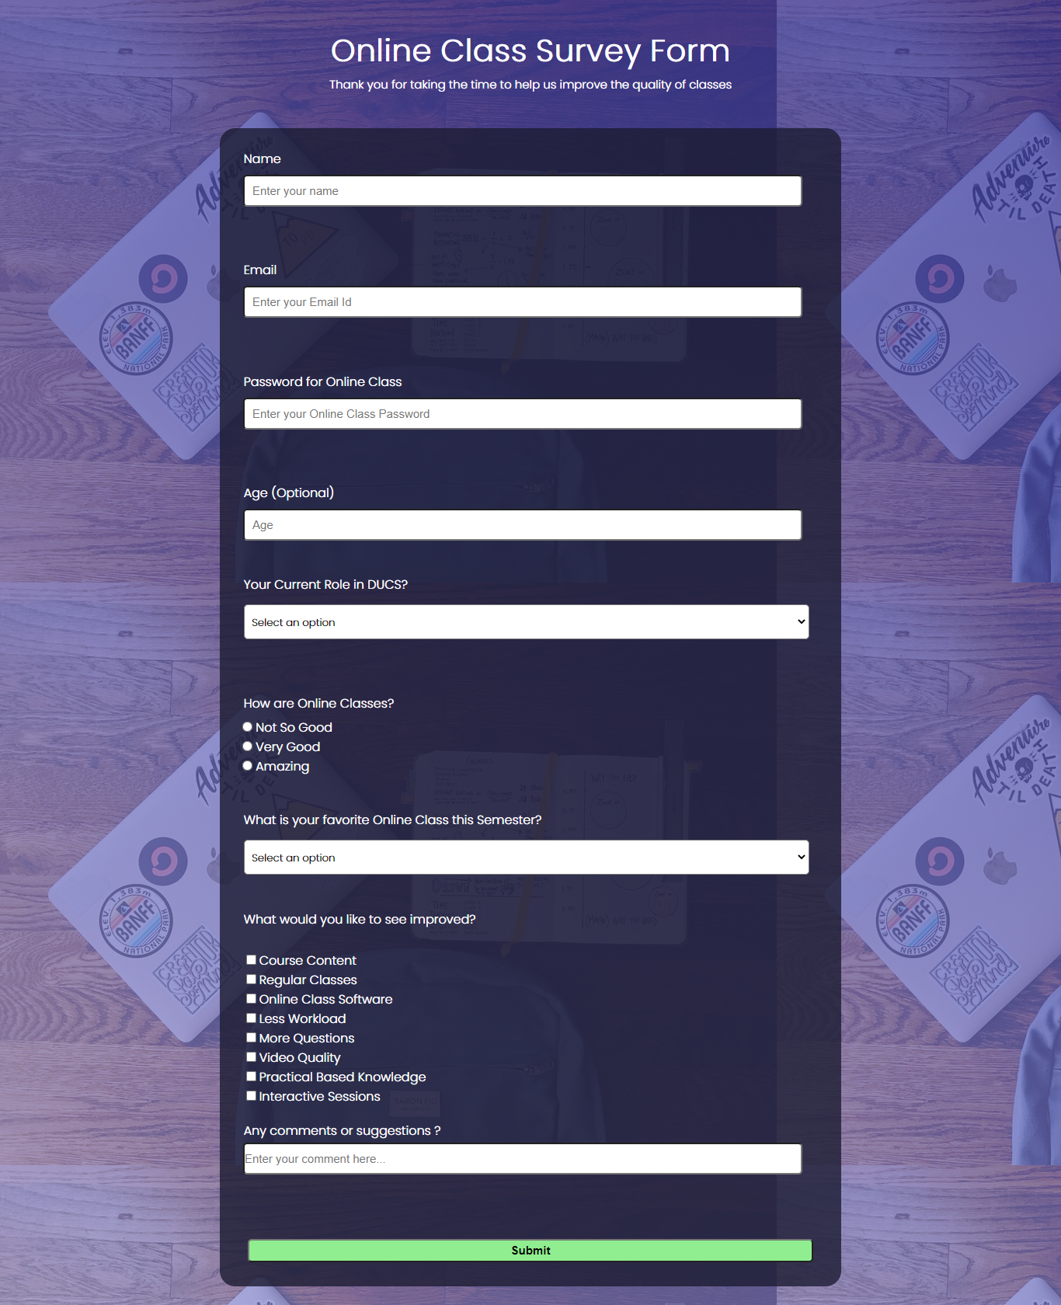

**Ques 2 Create an HTML table. Refer to the image below for the structure of table. You can change the content of the table**

table.html

<html>

<head>

    <h3 style="text-align: center;">Question 2(Tables in HTML)</h3>

</head>

<body>

<table ***border***="1" ***align***="center" width="400" height="150">

    <tr>

    <th rowspan="3">Day</th>

    <th colspan="5">Seminar</th>

    </tr>

    <tr>

    <th colspan="2">Schedule</th>

    <th colspan="3" rowspan="2">Topic</th>

    </tr>

    <tr>

    <th>Begin</th>

    <th>End</th>

    </tr>

    <tr>

        <td rowspan="2">Monday</td>

        <td rowspan="2" ***bgcolor***="#FFFFCD">8:00 a.m.</td>

        <td rowspan="2" ***bgcolor***="CDCEFF">5:00 p.m.</td>

        <td rowspan="1" colspan="3">Introduction to XML</td>

    </tr>

    <tr>

        <td rowspan="1" colspan="3">Validity: DTD and Relax NG</td>

    </tr>

    <tr>

        <td rowspan="5">Tuesday</td>

        <td rowspan="2" ***bgcolor***="#FFFFCD">8:00 am</td>

        <td rowspan="2" ***bgcolor***="#FFFFCD">11:00 am</td>

        <td rowspan="3">XPath</td>

    </tr>

      <tr></tr>

      <tr>

        <td rowspan="2" ***bgcolor***="#FFFFCD">11:00 am</td>

        <td rowspan="2" ***bgcolor***="#CDFFCD">2:00 pm</td>

      </tr>

      <tr>

        <td rowspan="2">XSL transformations</td>

      </tr>

      <tr>

        <td ***bgcolor***="#CDFFCD">2:00 pm</td>

        <td ***bgcolor***="CDCEFF">5:00 pm</td>

      </tr>

      <tr>

        <td>Wensday</td>

        <td ***bgcolor***="#FFFFCD">8:00 am</td>

        <td ***bgcolor***="#CDFFCD">12:00 pm</td>

        <td>XSL Formatting Objects</td>

      </tr>

</table>

</body>

</html>

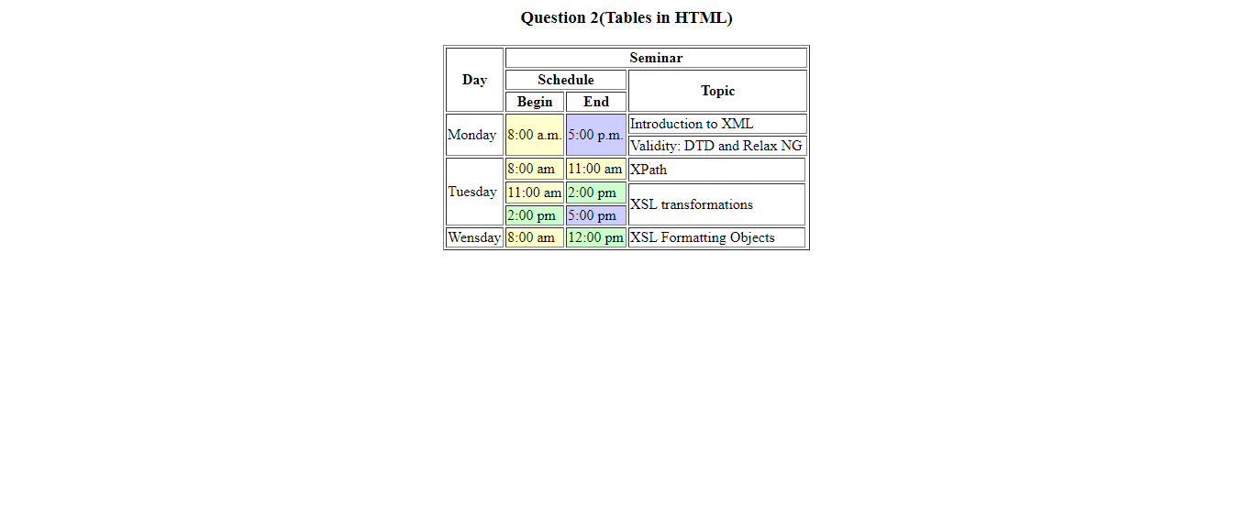

**Ques 3 Refer to the image below and create a webpage with similar structure of the webpage. You can change the content of the webpage.**

Web tech Q3.html

<html>

<head>

    <style>

        html,

        body {

            min-width: 290px;

            color: #ffffff;

            background-color: #46B9FE;

            font-family: "Open Sans", Arial, sans-serif;

            line-height: 1.5;

        }

        #navbar header {

            font-weight: bold;

            font-size: 25px;

            margin-left: 20px;

            margin-top: 10px;

        }

        #navbar {

            background-color: #040325;

            position: fixed;

            min-width: 290px;

            top: 0px;

            left: 0px;

            width: 300px;

            height: 100%;

            border-right: solid;

            border-color: rgba(0, 22, 22, 0.4);

        }

        #navbar ul {

            height: 88%;

            padding: 0;

            overflow-y: auto;

            overflow-x: hidden;

        }

        #navbar li {

            margin-top:15px;

            color: #ffffff;

            list-style: none;

            position: relative;

            width: 100%;

            vertical-align: center;

        }

        #navbar a {

            display: block;

            padding: 8px 100px;

            color: #ffffff;

            text-decoration: none;

            cursor: pointer;

        }

        .main {

            margin-left: 310px;

            padding: 20px;

            margin-bottom: -20px;

        }

    </style>

</head>

<nav id="navbar">

    <ul style="list-style-type:none;">

        <img src="VS.jpeg" style="height: 220px;width: 220px;margin-left: 30px;border-radius: 50%;">

        <li><a class="nav-link" href="#home">Home</a></li>

        <li><a class="nav-link" href="#interest">Interest</a></li>

        <li><a class="nav-link" href="#resume">Resume</a></li>

        <li><a class="nav-link" href="#education">Education</a></li>

        <li><a class="nav-link" href="#college">My College</a></li>

        <li><a class="nav-link" href="#meet">Meet ME</a></li>

    </ul>

</nav>

<section class="main" id="home">

    <h2> About Me </h2>

    <p>Hello, I'm Vasu Sehgal, currently pursuing MCA from Department of Computer Science, Delhi University. I have rich experience in Visual Design, Graphic Designing, Web Designing and Development.

    </p>

    <img src="vscode.jpeg" style="width: 800px;">

</section>

<section class="main" id="interest">

    <h2>Interest</h2>

    <p>I have Good Experience in Web-Designing, Web-Development and Graphic Designing. Being a Developer I love to solve and analyze Real World Problems.</p>

    <img src="webd.jpg" style="width: 800px;">

</section>

<section class="main" id="resume">

    <h2>Resume</h2>

    <p>Hello, I'm Vasu Sehgal, Web-Designer, Web-Developer based on Delhi. I have rich experience in Visual Design, Web Design, and Graphic Design. Also, I am good at:</p>

    <p>Adobe Illustrator, Adobe Photosop, HTML, CSS, JavaScript, PHP.</p>

    <img src="resume.jpg" style="width: 800px;">

    </section>

<section class="main" id="education">

    <h2>Education</h2>

    <p>

        I graduated from Bhaskaracharya College of Applied Sciences, University of Delhi in 2018. I did Bsc(hons) Computer Science. After that, I am pursuing MCA from Department of Computer Science, University of Delhi.</p>

        <img src="code.jpg" style="width: 800px;">

</section>

<section class="main" id="college">

    <h2>My College</h2>

    <p>The Department of Computer Science was established in the year 1981 with the objective of imparting quality education in the field of Computer Science. The Department has modern facilities for teaching, learning and research. The Department offers a wide array of research opportunities and programs of study at undergraduate and postgraduate level.</p>

    <p>Department started 3-year Master of Computer Applications (MCA) programme in the year 1982, which was among the first such programmes in India.</p>

    <img src="ducs.jpg" style="width: 800px;">

    </section>

<section class="main" id="meet">

    <h2> Lets Meet Over a Cup of Coffee </h2>

    <p>8th Floor, HB Twin Tower, Max Hospital Building, Netaji Subhash Place, Delhi, 110034</p>

    <img src="meet.jpg" style="width: 800px;">

</section>

</html>

